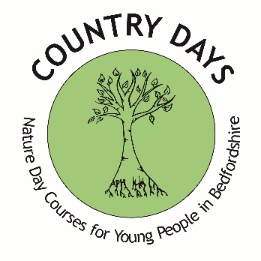
COUNTRY DAYS
The Leys Nature Reserve, Pavenham Road, Felmersham Beds MK43 7EX
The field is 6.0 acres and 1 3rd woodland with 33 native varieties of trees deciduous,fruit bearing and evergreen.
Pond area with great crested newts natural pathways and open field play area .2 compost toilets and a rain shelter with natural sedum roof

LETTINGS BOOKING FORM
Costs for this will be £25 hour, £60 for half day 9-12.30 /1.00-4.30 £100 per day
Name of Hirer: ___________________________________________________________________

Name of Organisation: ____________________________________________________________

Address for correspondence: ______________________________________________________

Telephone: Day: _______________________ Evening: ____________________________

Email address: __________________________________________________________________

Date(s) required: From: ___________ To: _________ Time of hire: From: ___________ To: _________

I agree to abide by the Terms & Conditions of Hire of Country days, and enclose a copy of your Insurance Policy.

Insurance Company: __________________________ Policy No: ____________________

Signed: ____________________________________ Date: ________________________

Total Amount Due: £________________

Cheques should be made payable to Country days

Payment can also be made by BACS to Country Days limited sort code 40 01 22 account 81808680
In line with GDPR please tick one of the following

I consent for Country Days to retain my information and use for marketing purposes.

I do not consent for Country Days to retain my information and use for marketing purposes.

Please go to www.countrydays.net to see our Privacy Notice.

For any queries please contact:
Post: PO Box 1591, Bedford, MK42 5DT
Tel: 07599336532 or 07938267057
Email: info@countrydays.net
Website: www.countrydays.net
Facebook: https://www.facebook.com/Countrydays1
Registered Charity Number 1181833

